**Heat Waves vs. Observed Data**

A few months back one of the commenters on this WUWT article: <https://wattsupwiththat.com/2021/07/12/the-truth-about-heat-waves/> posted a comment to the effect that the number of heatwaves is increasing, and cited this article on the EPA website: <https://www.epa.gov/climate-indicators/climate-change-indicators-heat-waves> . Embedded in the EPA article is this diagram:

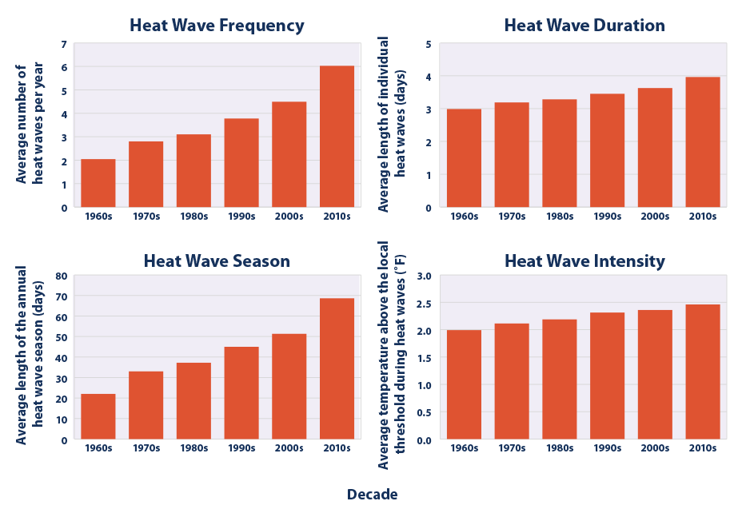

I was disappointed that the article doesn’t provide data, methodologies, or calculations. It also used some terms such as “the local threshold” and “heat wave season” without defining them. I was prompted by this comment to channel my inner Willis to see if I could replicate this chart.

**What is a heat wave?**

I started with the definition of a heat wave. I found several delightfully ambiguous definitions on the internet. From Mirriam Webster we have: “*a period of unusually hot weather*”; Wikipedia defines it as: “*A* [***heat wave***](https://en.wikipedia.org/wiki/Heat_wave) *is a prolonged period of unusually hot weather.*”; while from NOAA there is: “*A heat wave is simply* ***a period of unusually hot weather that typically lasts two or more days.*** *The temperatures have to be outside the historical averages for a given area.*” These definitions leave a lot of room for interpretation. Who gets to decide what is unusual? Historical averages over what period of time? Average over the whole period or a moving average? What is the local threshold and who determines its value? How far outside the historical averages?

**Getting Some Data**

I began my search for data by looking for some actual temperature records from my area. I wanted daily observed data, not monthly summaries or grid estimates. I live in central New Jersey, just outside of New York, and I was surprised to find that, despite the fact that there have been private colleges / universities and military bases from all branches within a stone’s throw of my house since the revolution, no local institution has recorded, or at least published, a historical daily temperature record. The best that Climate Data Online (<https://www.ncdc.noaa.gove/cdo-web/> could offer was three discontinuous data sets from different locations, the oldest starting... in 1960! On WUWT it’s often been stated that “climate is 30 years.” If I was to look for heat waves from the ‘60s that meant that I needed to find data from at least 1930 in order to look for heat waves in the 60s.

I poked around the internet and found some sources that had daily temperature observations in New York starting in the late 1800s:

High Plains Regional Climate Center: [High Plains Regional Climate Center - CLIMOD (unl.edu)](http://climod.unl.edu/) at the University of Nebraska Lincoln. This site has a good data set for New York’s Central Park.

Cornell University: [weather.nysaes.cals.cornell.edu/history/](http://weather.nysaes.cals.cornell.edu/history/) has records taken at their experimental farm outside of Geneva, NY.

I used Python scripts to scrape or parse these data sets into CSV files. There was some missing data, particularly in the early years, so discarded the records from before 1900. The Cornell site seems to have stopped posting half way through 2020, so I dropped the last six months of that data set to align with the end of 2019. There were still a few holes, so I filled in the gaps by calculating the average of the ten days before each gap and plugged the hole with that average.

|  |  |  |  |  |  |  |
| --- | --- | --- | --- | --- | --- | --- |
| Data Set | Date Range | Number of rows | Missing Highs | Missing Highs % | Missing Lows | Missing Lows % |
| New York Central Park | 1900 through 2020 | 44195 | 6 | 0 | 7 | 0 |
| Cornell | 1900 through 1999 | 43892 | 110 | .25% | 134 | .31% |

Temperature data sets used in this article

Back to the question of “usual temperature”. How do we determine the usual temperature for any given day of the year? It bothers me that we always think about usual / normal / average temperatures in terms of calendar months. A calendar month is a convenient fiction invented, in the case of our calendar, by the Romans. Months have little or nothing to do with actual climate related phenomena.

Rather than using an average of the days of a month, or the n days prior to a day, I thought it might make more sense to look at the temperatures for each individual day and location across the ~120 periods of each data set. This approach gives us a mean temperature for each day of the year that we can then use as the basis for our "two plus days above usual" evaluation. Using Python, Pandas, and Matplotlib I was able to quickly generate a data series for each day of the year over the ~120 years of each temperature record, calculate the mean, standard deviation, and a least squares trend line for each day, and plot these to see how the temperature has changed year over year for that day.

**120 Years of Daily Temperatures**

Every year citizens all across the US get together on the fourth of July, US Independence Day, to eat hot dogs, drink beer, and complain about how hot it is. A plot of the temperature on US Independence Day in Central Park from 1900 to 2020 looks like this:

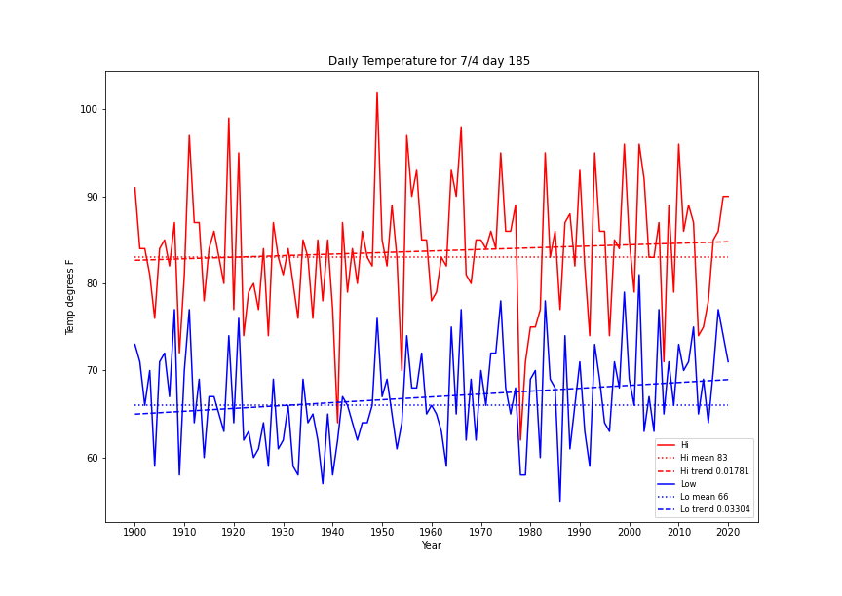

July Fourth in New York’s Central Park over a 120-year period - Is this why New Yorkers go to the Hamptons?

The mean in this graph is the mean high temperature value for this day of the year, in this case day 185.

Cornell University has an experimental farm not too far from Geneva, NY, about midway between Rochester and Syracuse. They’ve been collecting temperature data since 1891, though they stopped updating their web site mid-way through 2020. If we look at July 4 in Geneva from 1900 through 2019 we get a slightly different picture than the one in Central Park:

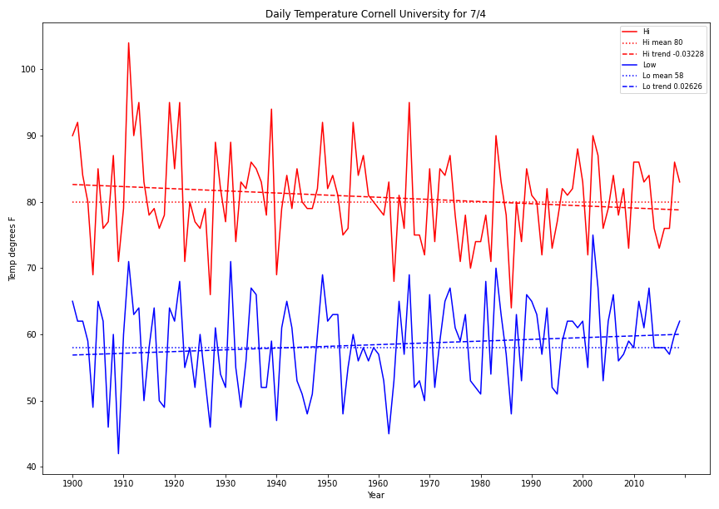

July Fourth in Geneva, NY over a 119-year period

It is interesting to note that the minimum temperatures in both locations have increased over the last 120 years.

I thought it might be fun to have a look at similar daily plots for some days that might actually be climate related – the solstices and equinoxes. Here is Central Park again:

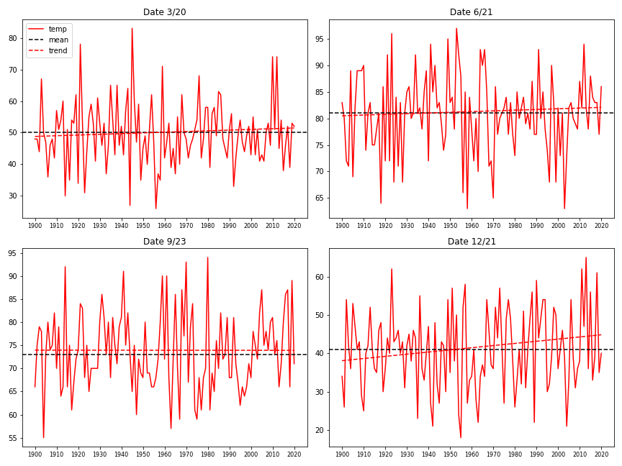

NY Central Park temperature of solstice/equinox days over the same 120-year period

The same four solstice / equinox days look like this in Geneva, NY:

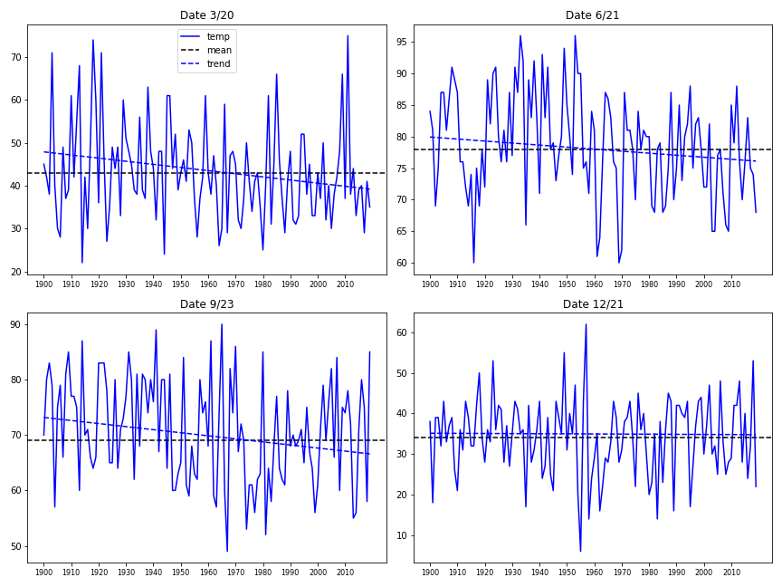

Temperature of the same solstice/equinox days in Geneva, NY over the same 119-year period

**Heat Waves**

To find the heat waves we need to find two or more consecutive days above normal. I decided to use one standard deviation above the mean temperature for that day of the year as “normal” for that day. I will do this for the entire year, not an arbitrary “heat wave season”. After all, if it is really warm in the middle of winter, isn’t that a heat wave?

To start, I identified every day above this threshold value. Here is the count of these ‘hot days’ per year in Central Park:

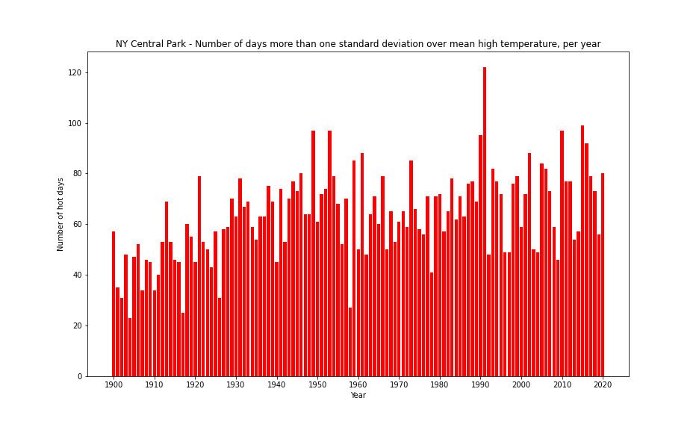

1992 had quite a few hot days in Central Park!

The plot of hot days for Geneva, NY looks like this:

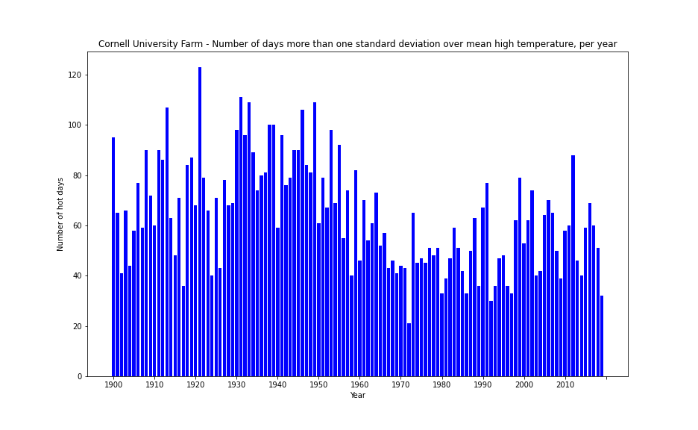

Those hot days seemed to occur in 1922 in upstate NY

From here it’s a simple matter to count the number of consecutive hot days to find the heat waves: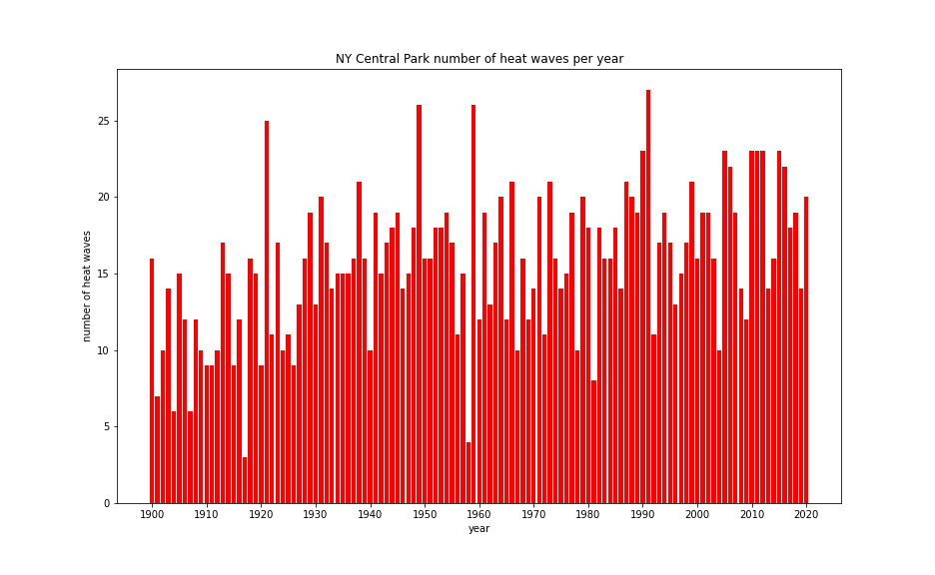

NY Central Park number of heat waves per year 1900 – 2020

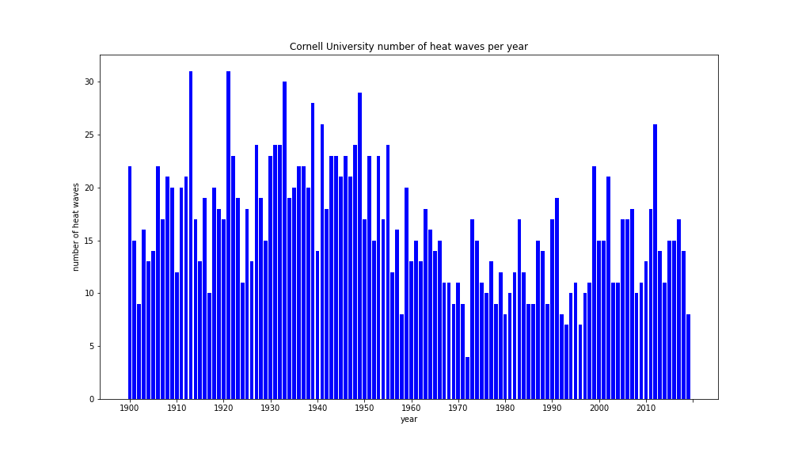

Geneva, NY number of heat waves per year 1900 – 2019

Now let’s look at intensity and duration. I’ll choose intensity to mean the average temperature of all heat waves that year.

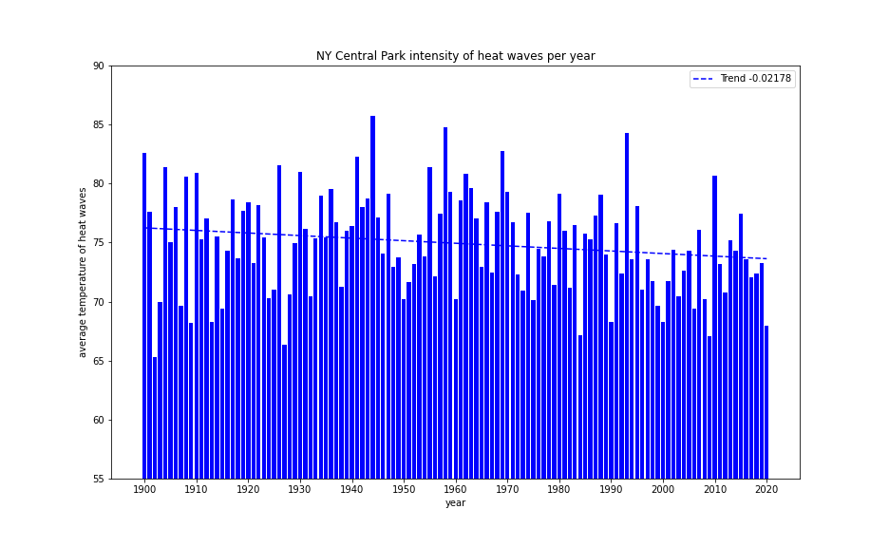

NY Central Park average temperature per heat wave per year 1900 – 2020

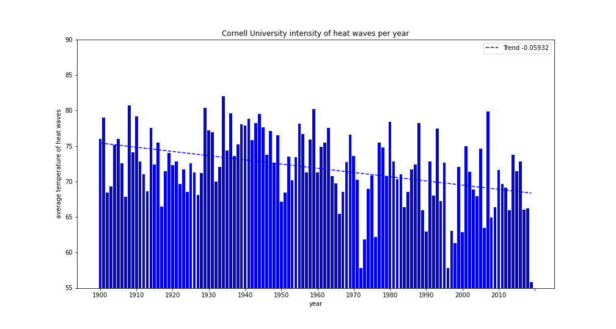

Geneva, NY average temperature per heat wave per year 1900 – 2019

These are interesting pictures. Does it mean that heatwaves are getting cooler, or that the percentage of heat waves in the cooler months has increased in the latter half of the data period?

Finally, we can plot the average length of the heat waves each year over the same period:

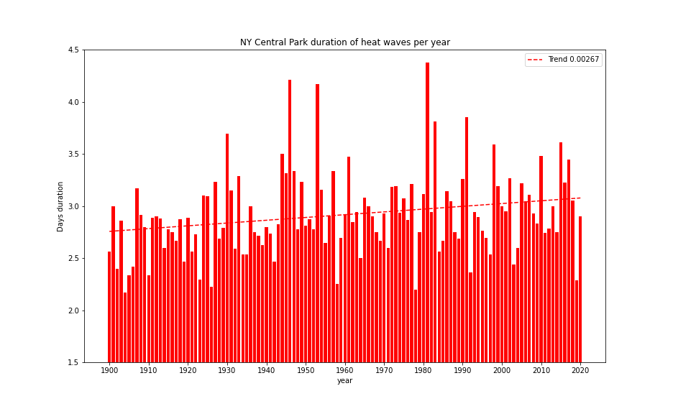

NY Central Park average duration of heat waves per year 1900 – 2020

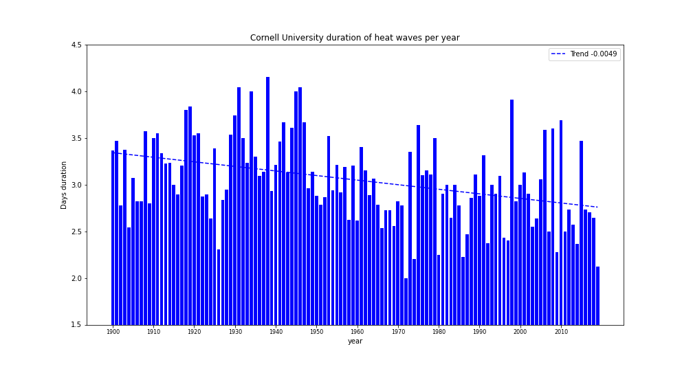

Heat wave average duration per year in upstate New York 1900 - 2019

**Summarizing by Decade – The EPA Chart**

Averaging the above heat wave numbers for each decade from 1900 – 2019 gives us charts similar to those provided by the EPA:

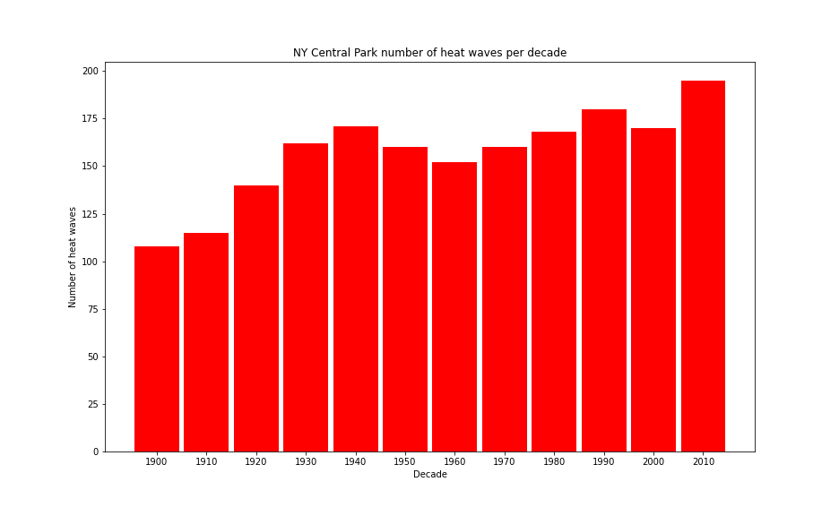

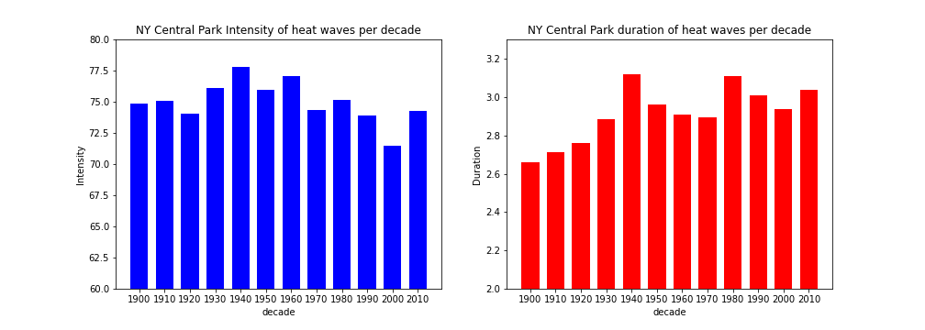

NY Central Park heat waves per decade 1900 – 2019

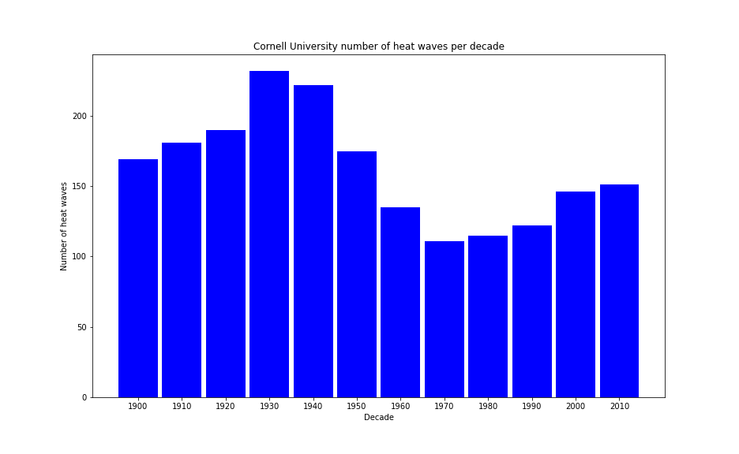

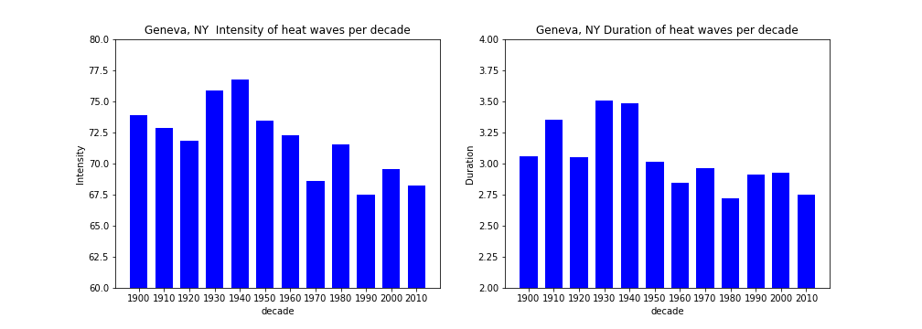

Cornell Experimental Farm, Geneva, NY heat waves per decade 1900 – 2019

Interestingly, the number of heatwaves per decade in both Central Park and upstate New York in the period 1960 - 2019 show an increase in the number of heat waves each decade, similar to the EPA graph, though it looks like they used a higher threshold because the number of heatwaves they cite is much lower. The period from 1960 to 2020 doesn’t appear to tell the whole story, though, as we can see that there was a warmer period in both data sets in the 30s and 40s. The intensity and duration charts that I’ve produced are quite different from EPA’s in each location.

**One Chart to Rule them All**

The EPA only had one set of charts representing an unspecified region, I suppose the whole Earth? I have two sets of charts, one for the city and one for upstate. Combining the two by averaging the decadal values for each location gives these plots:

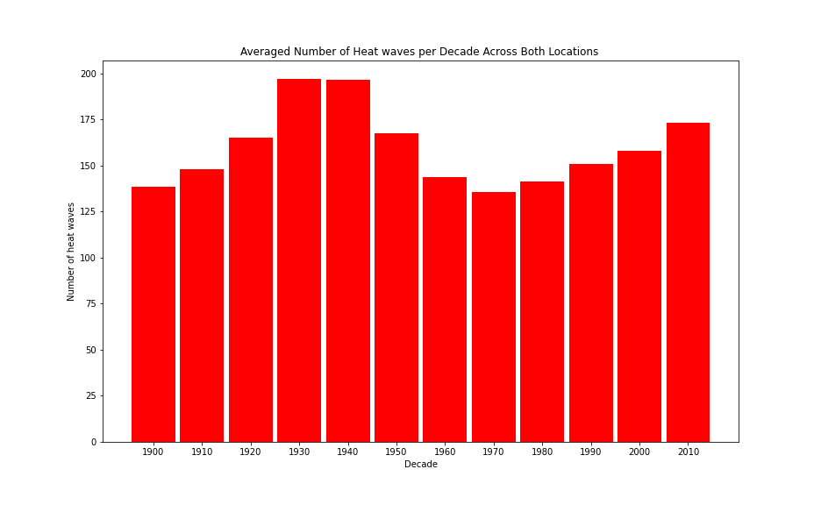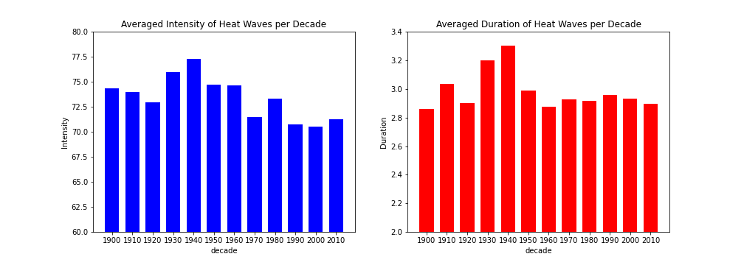

I’m not sure what these combined charts tell us. Averaging the counts of the heatwaves across the two locations does seem to mask the steady rise in the number of heatwaves in Central Park. The intensity and duration charts that we produced here bear no resemblance to those produced by the EPA. It would be nice to know what data they used to produce their charts.

What is clear is that a distance of approximately 300 miles and an altitude difference of 780 feet has produced very different temperature data in these two locations. The heatwave charts seem to show that even thirty years is not long enough to understand the climate in either location. It would be great to have another hundred years of data to see if that seemingly cyclical pattern in the number of heatwaves is real.

All data and calculations can be found here: https://github.com/jentwistle3/Heatwaves